CMD:

mvn archetype:generate -DgroupId=com.example.project -DartifactId=my-serenity-project -DarchetypeArtifactId=maven-archetype-quickstart -DinteractiveMode=false

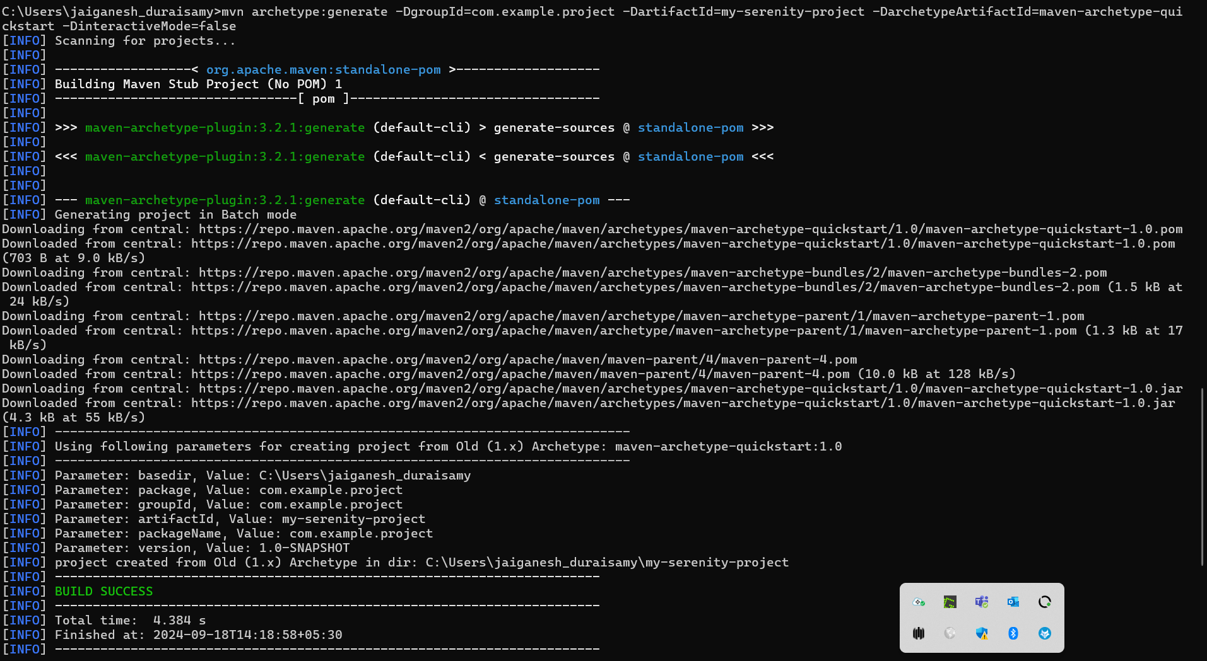

Mvn compile

Mvn test

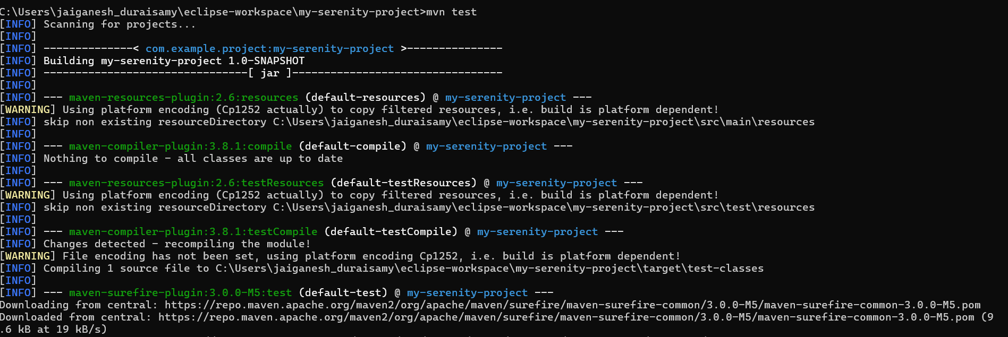

Mvn package

